Jarvis AI Desktop Voice Assistant

**What can this JARVIS A.I. assistant do :**

1 It can send emails on your behalf.

2 It can play music for you.

3 It can do Wikipedia searches for you.

4 It is capable of opening websites like Google, Youtube, etc., in a web browser.

5 It is capable of opening your code editor or IDE with a single voice command.

**Software**: Pycharm

**Step exp:**

**Defining Speak Function**

The first and foremost thing for an A.I. assistant is that they should be able to speak. To make our J.A.R.V.I.S. talk, we will make a function called speak(). This function will take audio as an argument, and then it will pronounce it.

**def speak(audio):**

**pass #For now, we will write the conditions later**.

Now, the next thing we need is audio. We must supply audio so that we can pronounce it using the speak() function we made. We are going to install a module called pyttsx3.

**pyttsx3:** A python library that will help us to convert text to speech. In short, it is a text-to-speech library.

It works offline, and it is compatible with Python 2 as well as Python 3.

import pyttsx3  
  
engine = pyttsx3.init('sapi5')  
  
voices= engine.getProperty('voices')  
print(voices[1])  
engine.setProperty('voice', voices[0].id)

**sapi5**: Microsoft developed speech API and Helps in synthesis and recognition of voice.

**VoiceId**:Voice id helps us to select different voices.

voice[0].id = Male voice

voice[1].id = Female voice

def speak(audio):  
 engine.say(audio)  
 engine.runAndWait()  
  
  
if __name__ == "__main__":  
 speak("Code With Parikshit")

speak() function to convert our text to speech.

Whatever you will write inside this speak() function will be converted into speech. Congratulations! With this, our J.A.R.V.I.S. has its own voice, and it is ready to speak.

**Defining Wish me Function :**

To provide current or live time to A.I., we need to import a module called DateTime. Import this module to your program.

def wishMe():  
 hour=int(datetime.datetime.now().hour)  
 if hour>=0 and hour<12:  
 speak("Good Morning!")  
 elif hour>=12 and hour<18:  
 speak("Good Afternoon!")  
 else:  
 speak("Good evening")  
 speak("Hey Parikshit, I am Jarvis sir. Please tell me how may I help you")  
if __name__ == "__main__":  
 wishMe()

**Defining Take command Function :**

Before defining the takeCommand() function, we need to install a module called speech recognition. Install this module by

**pip install speechRecognition**

After successfully installing this module, import this module into the program by writing an import statement.

**import speechRecognition as sr**

def wishMe():  
 hour=int(datetime.datetime.now().hour)  
 if hour>=0 and hour<12:  
 speak("Good Morning!")  
 elif hour>=12 and hour<18:  
 speak("Good Afternoon!")  
 else:  
 speak("Good evening")  
 speak("Hey Parikshit, I am Jarvis sir. Please tell me how may I help you")  
  
def takeCommand() -> object:  
 r = sr.Recognizer()  
 with sr.Microphone() as source:  
 print("Listening...")  
 r.pause_threshold = 1  
 audio = r.listen(source)  
 try:  
 print("Recognizing...")  
 query = r.recognize_google(audio, language='en-in') # Using google for voice recognition.  
 print(f"User said: {query}\n") # User query will be printed.  
  
 except Exception as e:  
 # print(e)  
 print("Say that again please...") # Say that again will be printed in case of improper voice  
 return "None" # None string will be returned  
 return query  
if __name__ == "__main__":  
 wishMe()  
 takeCommand()

**output**

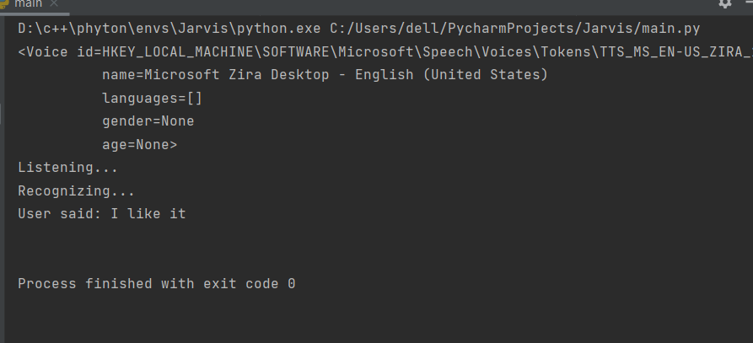

**Defining Task 1: To search something on Wikipedia**

pip install wikipedia

query = takeCommand().lower()  
if 'wikipedia' in query:  
 speak("Searching wikipedia...")  
 query=query.replace("wikipedia","")  
 results = wikipedia.summary(query, sentences=2)  
 speak("According to Wikipedia")  
 print(results)  
 speak(results)

**Task 2: To open site in a web-browser**

elif 'open youtube' in query:  
 webbrowser.open("youtube.com")  
elif 'open facebook' in query:  
 webbrowser.open("facbook.com")  
elif 'open instagram' in query:  
 webbrowser.open("instagram.com")  
elif 'open google' in query:  
 webbrowser.open("google.com")

**To know the current time**

elif 'the time' in query:  
 strTime = datetime.datetime.now().strftime("%H:%M:%S")  
 speak(f"Sir, the time is {strTime}")  
 print(strTime)

**Task 7: To send Email**

To send an email, we need to import a module called smtplib.

**smtplib:**

Simple Mail Transfer Protocol (SMTP) is a protocol that allows us to send emails and to route emails between mail servers. An instance method called sendmail is present in the SMTP module. This instance method allows us to send an email. It takes 3 parameters:

The sender: Email address of the sender.

The receiver: T Email of the receiver.

The message: A string message which needs to be sent to one or more than one recipient.

def sendEmail(to, content):  
 server = smtplib.SMTP('smtp.gmail.com', 587)  
 server.ehlo()  
 server.starttls()  
 server.login('ps.kamrunag87@gmail.com', '**********')  
 server.sendmail('ps.kamrunag87@gmail.com', to, content)  
 server.close()

elif 'email to Ram' in query:  
 try:  
 speak("What should I say?")  
 content=takeCommand()  
 to="ps.kamrunag87@gami.com@gmail.com"  
 sendEmail(to, content)  
 speak("Email has been sent!")  
 except Exception as e:  
 print(e)  
 speak("Sorry my friend Parikshit bhai. I am not able to send this email")

**code:**

import pyttsx3  
import wikipedia  
import datetime  
import speech_recognition as sr  
import webbrowser  
import os  
import smtplib  
engine = pyttsx3.init('sapi5')  
  
voices= engine.getProperty('voices')  
print(voices[1])  
engine.setProperty('voice', voices[0].id)  
  
def speak(audio):  
 engine.say(audio)  
 engine.runAndWait()  
def wishMe():  
 hour=int(datetime.datetime.now().hour)  
 if hour>=0 and hour<12:  
 speak("Good Morning!")  
 elif hour>=12 and hour<18:  
 speak("Good Afternoon!")  
 else:  
 speak("Good evening")  
 speak("Hey Parikshit, I am Jarvis sir. Please tell me how may I help you")  
  
def takeCommand() -> object:  
 r = sr.Recognizer()  
 with sr.Microphone() as source:  
 print("Listening...")  
 r.pause_threshold = 1  
 audio = r.listen(source)  
 try:  
 print("Recognizing...")  
 query = r.recognize_google(audio, language='en-in') # Using google for voice recognition.  
 print(f"User said: {query}\n") # User query will be printed.  
  
 except Exception as e:  
 # print(e)  
 print("Say that again please...") # Say that again will be printed in case of improper voice  
 return "None" # None string will be returned  
 return query  
def sendEmail(to, content):  
 server = smtplib.SMTP('smtp.gmail.com', 587)  
 server.ehlo()  
 server.starttls()  
 server.login('ps.kamrunag87@gmail.com', '**********')  
 server.sendmail('ps.kamrunag87@gmail.com', to, content)  
 server.close()  
  
if __name__ == "__main__":  
 wishMe()  
 while True:  
 query=takeCommand().lower()  
 if 'wikipedia' in query:  
 speak("Searching wikipedia...")  
 query=query.replace("wikipedia","")  
 results = wikipedia.summary(query, sentences=2)  
 speak("According to Wikipedia")  
 print(results)  
 speak(results)  
 elif 'open youtube' in query:  
 webbrowser.open("youtube.com")  
 elif 'open facebook' in query:  
 webbrowser.open("facbook.com")  
 elif 'open instagram' in query:  
 webbrowser.open("instagram.com")  
 elif 'open google' in query:  
 webbrowser.open("google.com")  
 elif 'play music' in query:  
 music_dir='D:\music'  
 songs = os.listdir(music_dir)  
 print(songs)  
 os.startfile(os.path.join(music_dir, songs[0]))  
 elif 'the time' in query:  
 strTime = datetime.datetime.now().strftime("%H:%M:%S")  
 speak(f"Sir, the time is {strTime}")  
 print(strTime)  
 elif 'open code' in query:  
 codePath="C:\\Program Files (x86)\\Dev-Cpp\\devcpp.exe"  
 os.startfile(codePath)  
 elif 'email to Ram' in query:  
 try:  
 speak("What should I say?")  
 content=takeCommand()  
 to="ps.kamrunag87@gami.com@gmail.com"  
 sendEmail(to, content)  
 speak("Email has been sent!")  
 except Exception as e:  
 print(e)  
 speak("Sorry my friend Parikshit bhai. I am not able to send this email")